RESUME
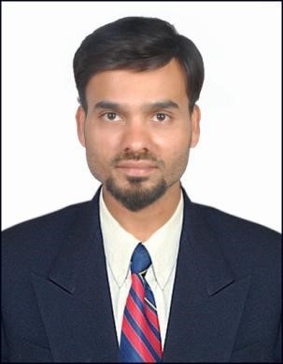

ASHOK
No 35 1st floor,
Green Avenue Condominium, Bukit Jalil
50470 Kuala Lumpur.

Valid Personal Email : ashokboy.0011@gmail.com

Contact Number : +60138776001

OBJECTIVE
Intend to build a career with leading Corporate of Hi-tech environment with Committed & dedicated
people, which will help to explore myself fully and realize my potential in every Sector possible.

PERSONAL DETAILS
Name : Ashok
Age : 31
Birth of Date : 07/06/1989
Status : Single
Languages Knows : English, Tamil, Malay

ACADEMIC QUALIFICATIONS

Year Higher School / College / University Name Major/Course

2008-2014 MSU University Bachelor of Business
Management

SKILL
- Strong analytical and problem solving skills.
- Good communication skills in Written and verbal both.
- Highly trustworthy, discreet and ethical.
- Resourceful in the completion of projects, effective at multi-tasking.
- High level Numeracy.
- Organizational Skills and ability to manage deadlines.

Total working experience : 4 yrs

WORKING EXPERIENCE

Jan 2016- Jan 2020

GM Trading S.B , Kuala Lumpur, Malaysia.

Financial System Analyst

Duties of work

- Assist in financial data clean up exercise.
- Handling ad-hoc assignment as and when tasked by immediate supervisor/Management.
- Participating in the design and maintenance of internal reporting platform. Assist in charge or enhancement of reporting platform to improve efficiency and accuracy of analysis.
- To support Regulators/BNM queries and assignment pertaining to the Bank’s financial data.
- Project Controlling: To assist the controller in budgeting and cost management activities.
- To assist with analysis of incoming and outgoing of funds and to identify gaps for cash flow optimization.
- To assist controller to improve the process of cash forecasting.
- To assist the controller in bank reconciliation and operation banking matters.
- Provide financial analysis support to technical team leads while assisting them in achieving their recovery target.

INTERESTS

- Internet Surfing
- Listening music
- Reading Books

REFERENCES

GM TRADING SDN BHD
Mdm Zulaiha, Branch Manager
+6032999 1984

Declaration

I hereby declare that the information furnished above is true to the best of my knowledge and I shall oblige if I am given an opportunity to work in your organization
(ASHOK)

